NAME OF STUDENT:
PROGRAM/YR/SECTION:
INSTRUCTOR:
MODULE 6

TOPIC – SCULPTURE
6.1 The Origin of Sculpture
6.2 Importance of Sculpture
6.5 Types of Sculptures
6.6 Medium and Techniques
6.7 Basic Sculpture Terms

TIME FRAME: 5 hrs.

INTRODUCTION
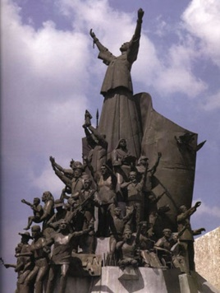
Sculpture is one of the oldest of all art forms. Artists have been using rock to carve pieces for many centuries. Today, this ancient art is still quite popular. Many sculptures today still work to help us all explore space and understand how metal and other materials can be full of life and movement even when still. An understanding of this kind of art is vital in order to fully understand the world of art. Those who study sculpture up close are often amazed at just how ordinary objects can be made new and turned into art with a few simple steps.
Figure 1 People Power Monument. Photo from eduardocastrillo.

OBJECTIVES
At the end of this lesson, students are expected to:

- Discuss the origin of sculpture;
- Recognize the importance of sculpture;
- Demonstrate knowledge about the type, medium, and technique of sculpture; and,
- Create works of art in sculpture using clay and soap.

PRE-TEST
Direction. Look in places around you and take a photo of something that is considered a product of a sculptor then answer these questions:

1. What is the sculpture about? Describe it.
2. Why do you think sculptures are displayed publicly?
3. Does the appearance of the surface of the material influence your feelings or thoughts? How?

LEARNING ACTIVITIES

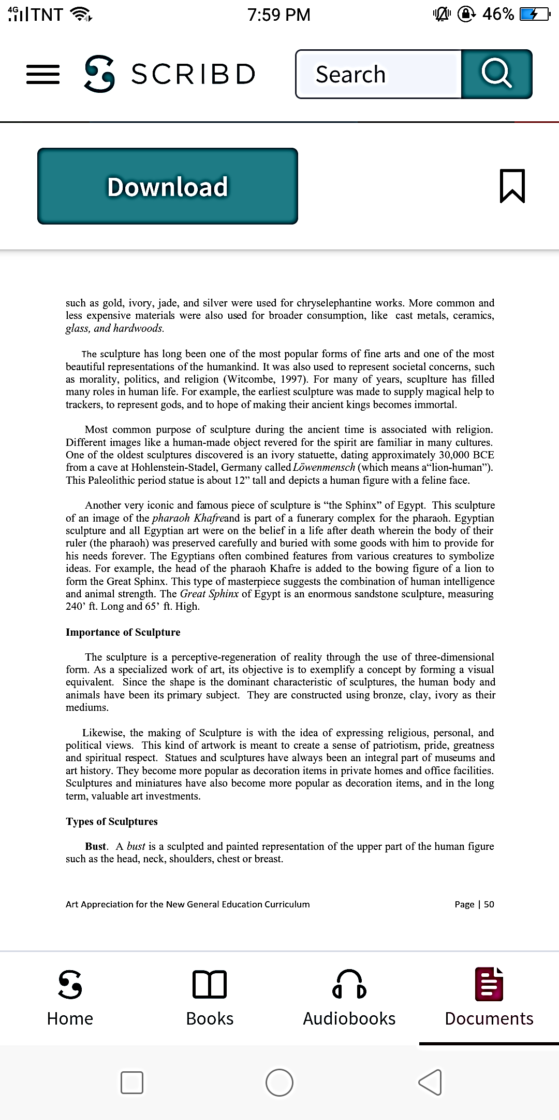
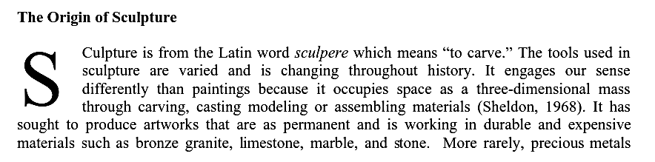
Assigned Reading/text

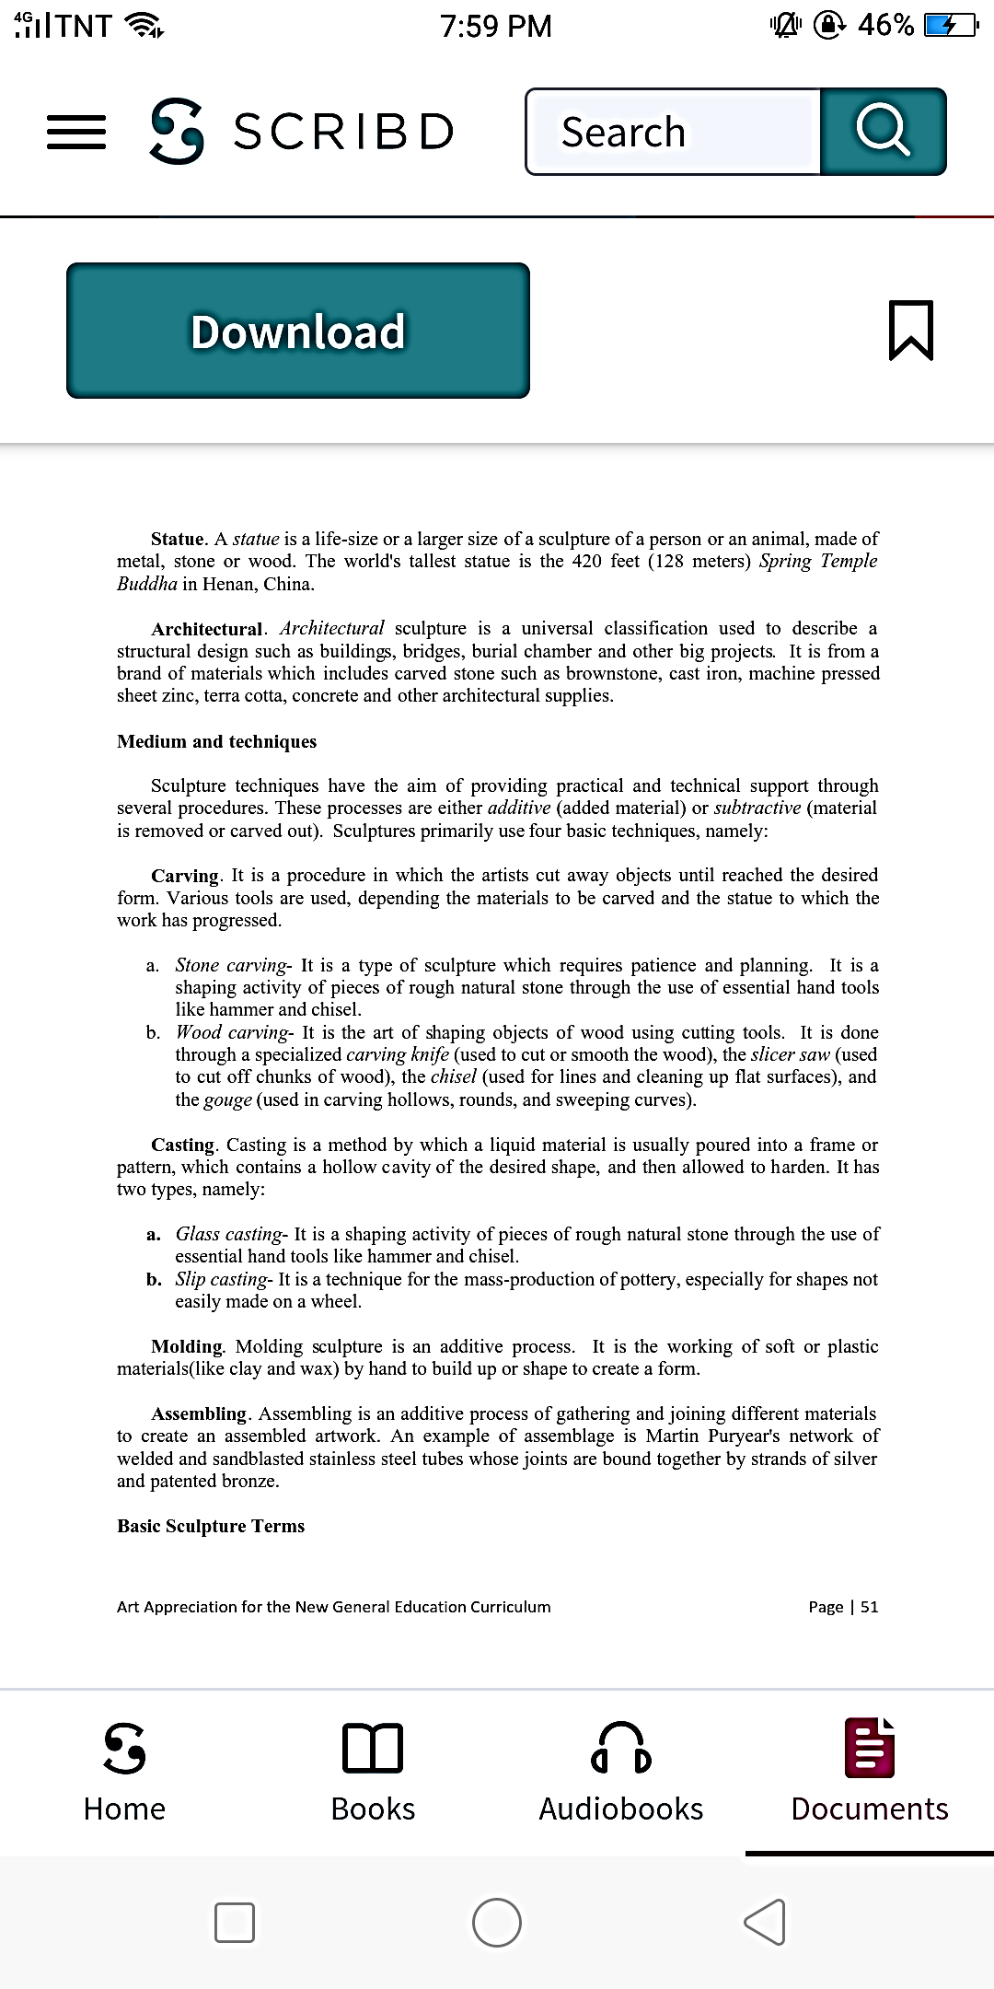
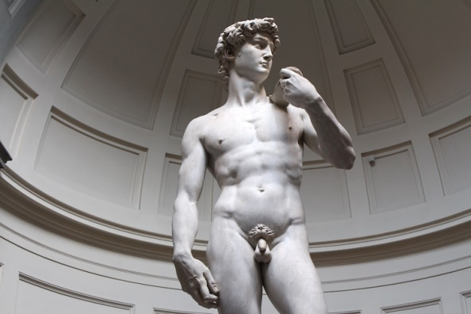
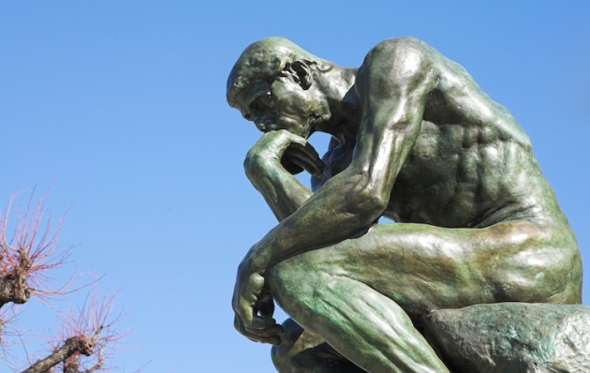
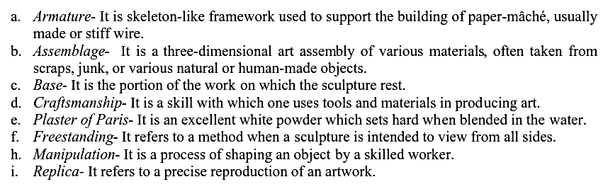
Figure 2 A cast of “The Thinker” by Rodin. (Photo: Stock Photos from Sean Neal/Shutterstock)

Figure 3 “David” by Michelangelo. (Photo: Stock Photos from Marta Pons Moreta/Shutterstock)


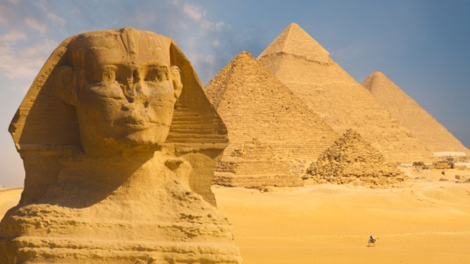
Figure 4 The Great Sphinx of Giza

Figure 5 Christ the Redeemer in Rio de Janeiro, Brazil byPaul Landowski

SELF-EVALUATION

Soap Sculptures

Soap carving is a way to create sculptures from a bar of soap. As opposed to wood carving, which is more dangerous and should only be done by skilled individuals, anyone can enjoy carving creations from soap. Creative soap sculpture can then be displayed, or used as soap.
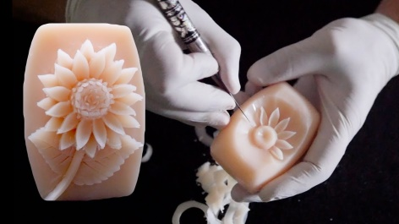
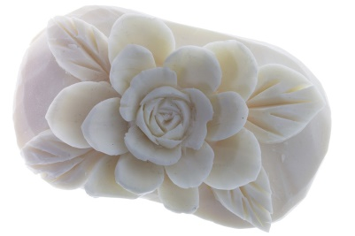
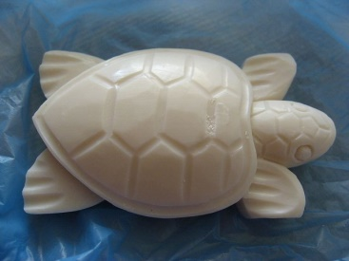

Soap Sculpture Examples

Required Tools:

Bar Soap
Pencil
Carving Tool (knife, blade cutter, spoon, popsicle stick)

Instructions:

1. Choose a bar soap. A bigger bar is easier to hold and gives more material to work within the well-covered area. The tools that you’ll use for carving the soap are pencils, craft sticks (the ones that look like sticks), toothpicks, and possibly a fork or other tools (depending upon the design that you have in mind).

2. Choose a tool to use. Popsicle sticks, plastic knives or spoons can be used as simple tools in carving. Begin by gently holding the soap in your off-hand, making sure not to hold it too tightly or else you could crush it or overheat it.

3. Using your pencil, very lightly sketch any major parts of your design directly onto the soap. You could also use a fine-tipped permanent maker for this, though certain types of markers may absorb into the soap. Decide on what particular design you would like to make.

4. Take one of your craft sticks and, using gentle-yet-firm motions, begin scrapping of small portions of the soap bar.

5. As you gradually start to form the soap into the shape that you want, use toothpicks, forks, or other household items to create a detailed work or surface.

6. To smooth rough patches of your soap use your fingers. Your body heat will serve as to soften the soap, making it easier to create a smooth surface.

7. Once you’ve completed your soap sculpture, store it in a cool and dry location.

8. Take a photo of it and explain why you made that artwork. What is the essence of it? Submit it on Google Classroom.

REVIEW OF CONCEPTS

Rough - Sketchy version of a piece, done quickly and without much detail at the design stage, but already showing its final visual appearance.
Abstractionism

Abstractionism - is defined as art that has no reference to any figurative reality. In its wider definition, abstract art is what depicts real forms in a simplified or rather reduced way keeping only an allusion to the original natural subject.

Atélier - A French word meaning "studio" and referring precisely to the place where an artist works.

Mould - An impression of a relief or statue, produced by coating the model with a ductile material (wax, clay, plaster) which is subsequently removed to obtain a die, giving the most faithful or mechanically objective copy (usually through plaster casting) of the original sculpture.

Conceptual - Conceptual art is a contemporary form of artistic representation, in which the concept or idea that the artwork represents is considered more important than, and takes precedence over, traditional aesthetic and material concerns.

Figurative - Figurative art describes artwork which portrays mainly the human or animal figure.

Sketch - The first, hastily executed drawing done by the artist, a form of "pictorial" note-taking aimed at capturing an inspiration, an initial idea of the artwork to come.

POST-TEST

Essay: Answer the ff. questions concisely. (Avoid plagiarizing answers online)

1. Why is sculpture considered as one of the most popular forms of fine arts? Explain.

2. What are the interpretations that are commonly expressed in sculpture?

3. If you are a sculptor, what technique and medium do you like most?

4. What are the goals of an artist in creating a sculpture? Explain.

5. Explain how sculpture is associated with Religion and the Military.

REFERENCES

Ramos, Arnulfo B. (2018). Art Appreciation for the New General Education Curriculum. First Edition. 65 Arellano St., Davao City: SMKC Printshoppe

http://rolands-art.org/all-about-sculpture/

